# COMP9318 Logistic Regression

* Discriminative models:

For example we only consider the probability of 0 and probability of 1.

Consider discrete models.

**Logistic Regression is a classification method, but why it is called regression.**

Because, it is a method to adjust liner regression to classification

1. liner regression

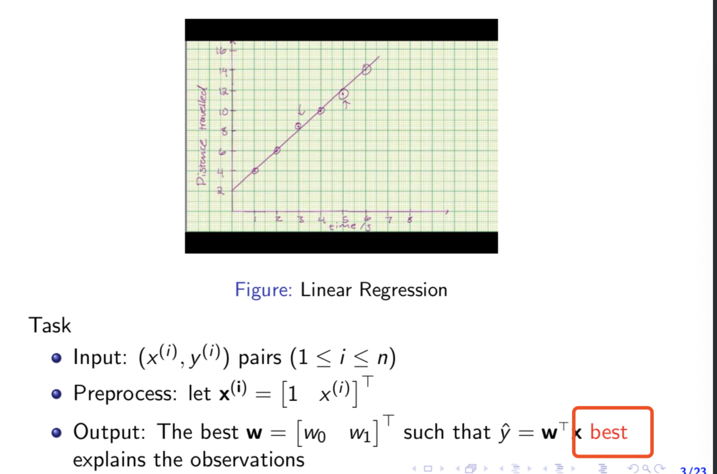

How to define ‘best’??

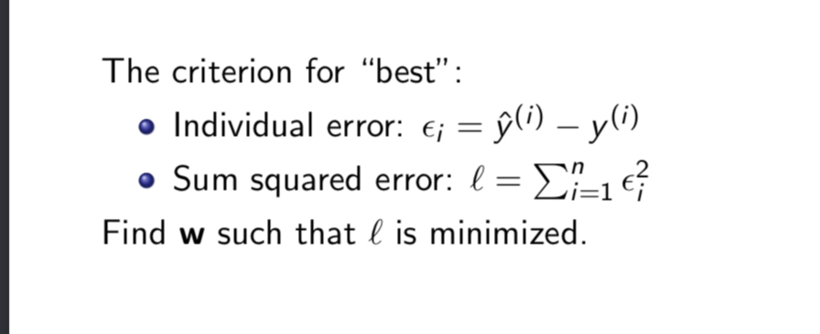

We use Taylor series to do the minimization

Given a, use Taylor series to evaluate a x* relatively close to a.

1. Logistic Regression

Unknow parameter is pi, the probability [0,1]

Task is to find a function which matches real domain to [0,1] domain.

It turns out there is a function called sigmoid function which helps us out here.

$$g\left(z\right)=\frac{1}{1+e^{-z}}$$

## 要了解更多信息并获取 OneNote，请访问 [www.onenote.com](http://go.microsoft.com/fwlink/?LinkID=523891)。